Computer Networks

Lab Task #6

Saad Ahmad

20P-0051

Task#1

Add 2x PCs, 1x Switch and 2x Server.

Connect them with cables.

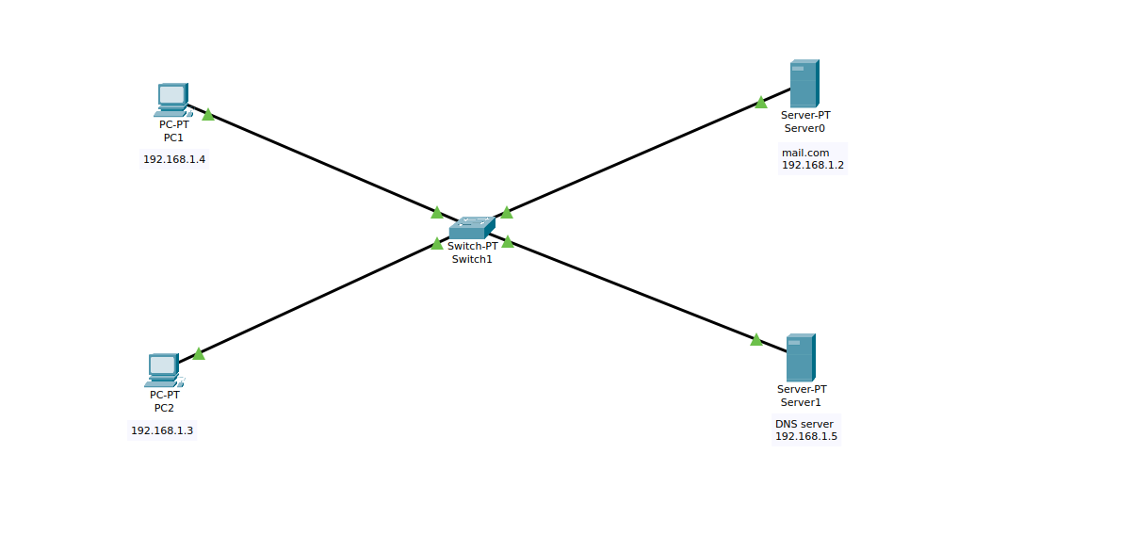

Now assign the static IPs to the PCs

PC1

**IP:** 192.168.1.4

**Subnet mask:** 255.255.255.0

**DNS Server:** 192.168.1.5

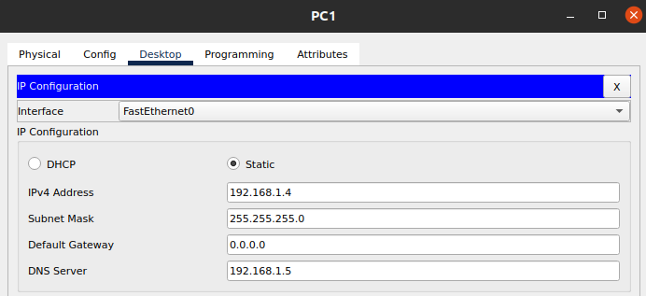

PC2

**IP:** 192.168.1.3

**Subnet mask:** 255.255.255.0

**DNS Server:** 192.168.1.5

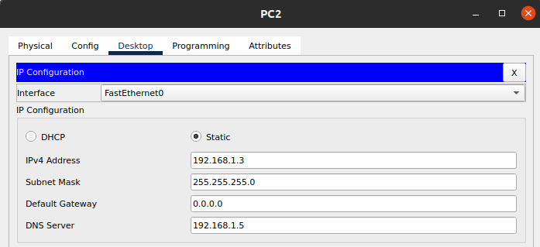

And now configure the emails on both PCs

PC1:

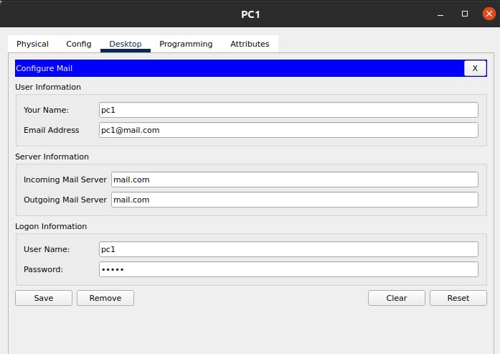

PC2

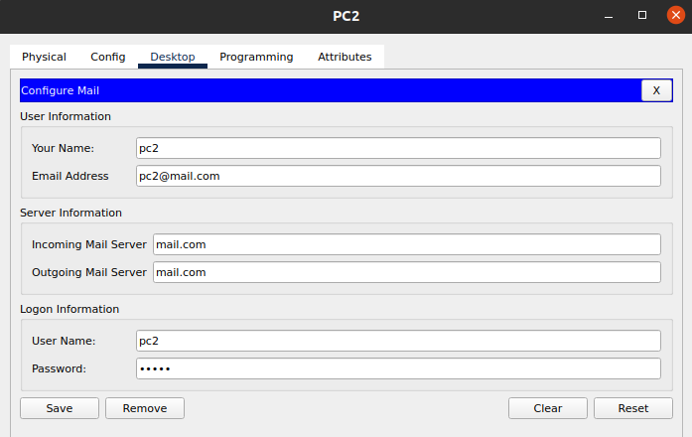

Now assign the static IP to the server

**IP:** 192.168.1.2

**Subnet mask:** 255.255.255.0

**DNS Server:** 192.168.1.5

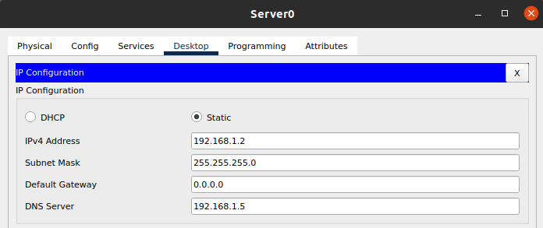

And now add the details of the clients in the server under the email tab.

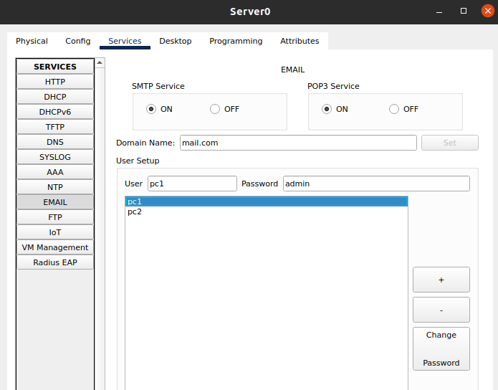

Now assign the static IP to the DNS Server.

**IP:** 192.168.1.5

**Subnet mask:** 255.255.255.0

**DNS Server:** 192.168.1.5

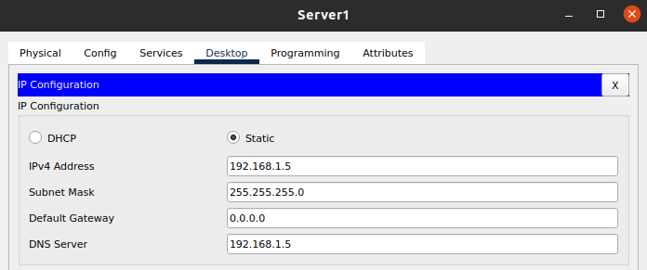

now add the “mail.com” to the DNS server.

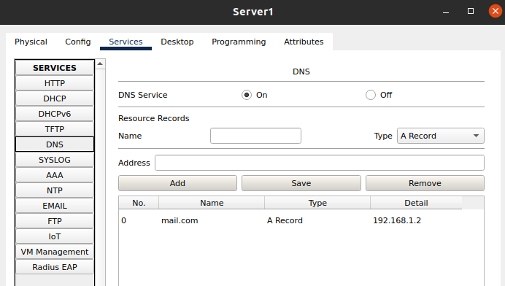

**Results:**

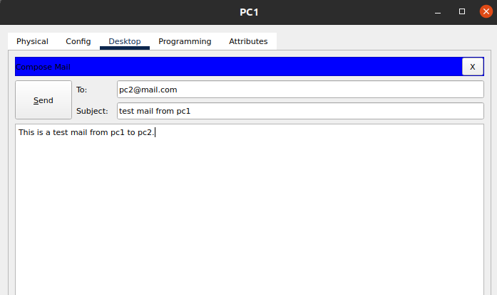Sending the mail form PC1 to PC2.

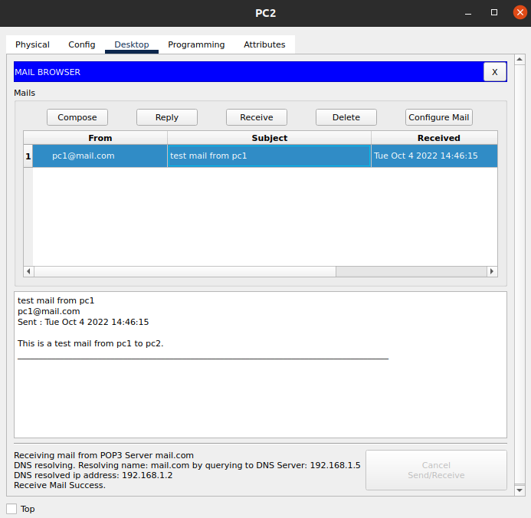

Receiving the mail from PC1 on PC2

Task #2

File Transfer Protocol (FTP)

Add 1x PCs, 1x Switches and 1x Server.

And connect them with cables.

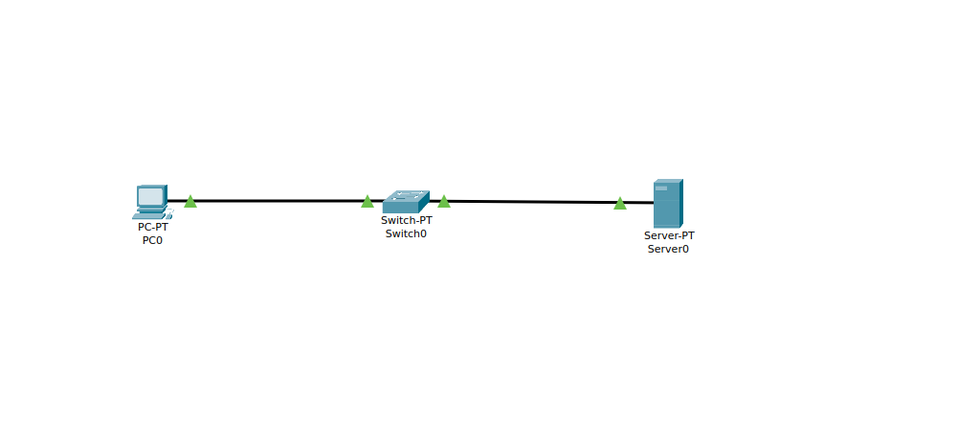

Now assign the static IP to the PC Sever

**IP:** 192.168.1.1

**Subnet mask:** 255.255.255.0

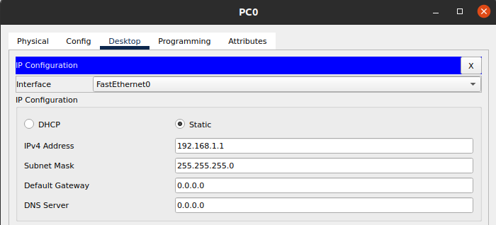

and now we will assign the static IP to the sever.

**IP:** 192.168.1.2

**Subnet Mask:** 255.255.255.0

Now create a txt file on your system.

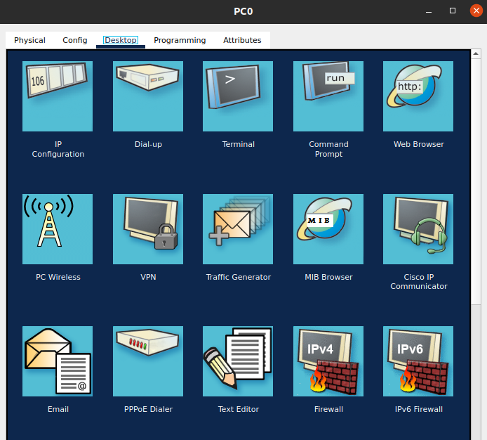

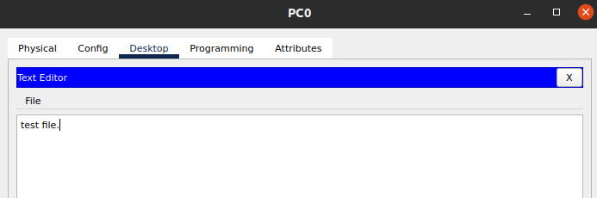

And save the file.

Now open the command prompt on your PC and type the following command.

Ftp <ip of the server>

ftp 192.168.1.2

enter the username and the password

username = cisco

password = cisco

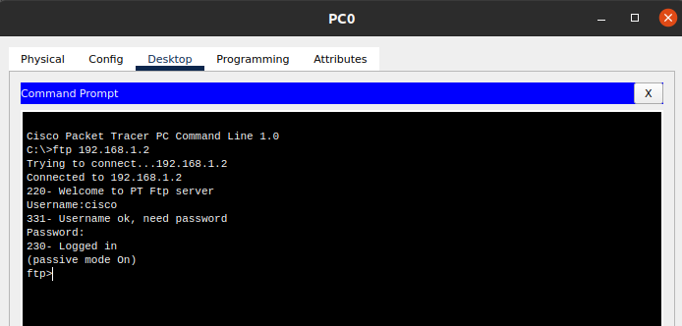

And now put the file on the server.

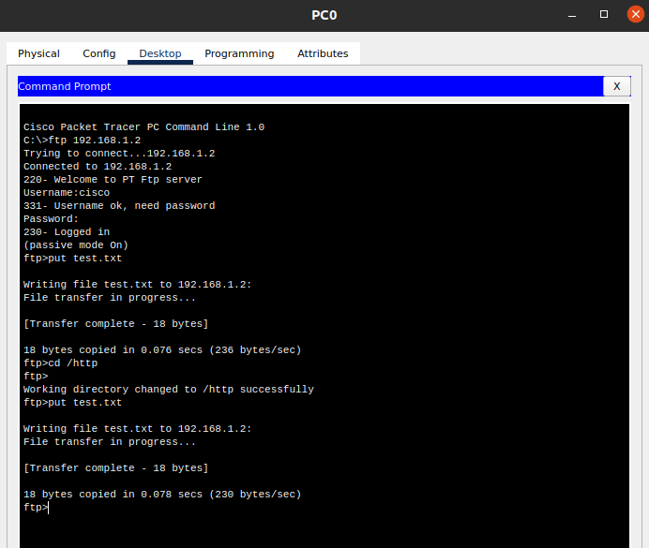

**Result:**

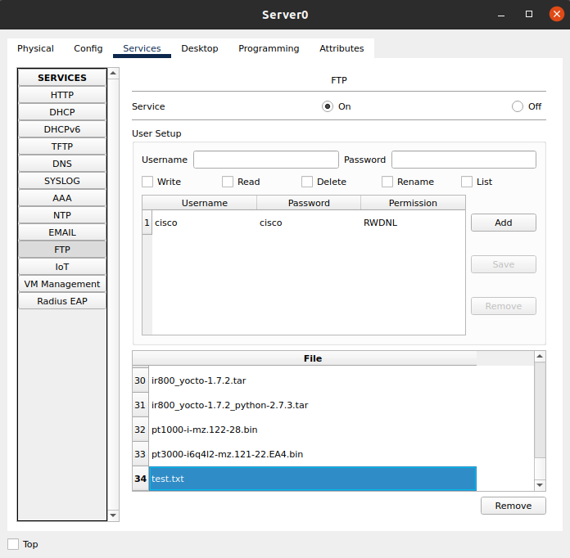

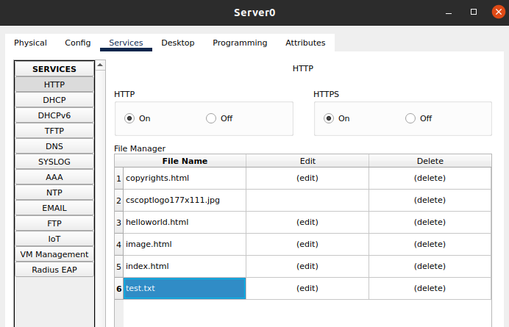

Task #3

Add 1x PCs, 1x Switches and 1x Server.

And connect them with cables.



Now assign the static IP to the PC Sever

**IP:** 192.168.1.1

**Subnet mask:** 255.255.255.0



and now we will assign the static IP to the sever.

**IP:** 192.168.1.2

**Subnet Mask:** 255.255.255.0

Now create a html file on your system.



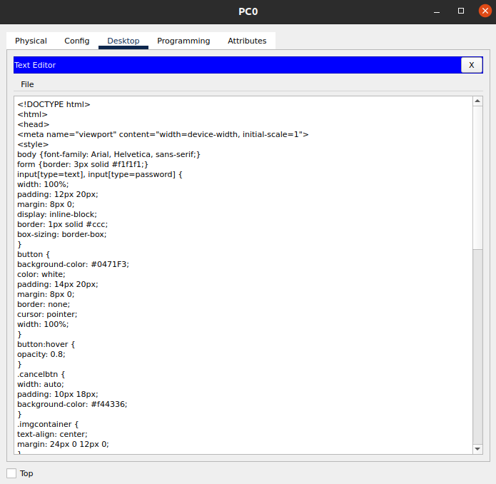

And save the file.

Now open the command prompt on your PC and type the following command.

Ftp <ip of the server>

ftp 192.168.1.2

enter the username and the password

username = cisco

password = cisco



And now put the file on the server and in the http directory



Now check the file.

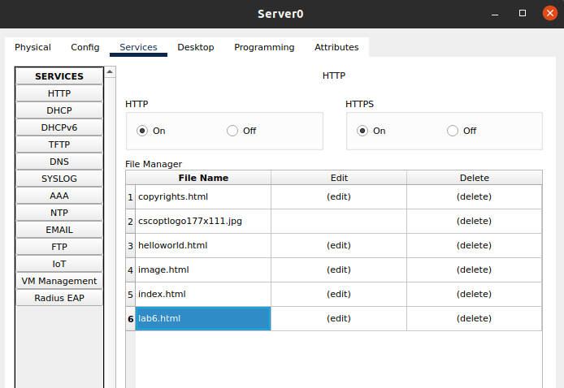

Now open the browser in your PC and run the following IP in the address bar

http://192.168.1.2

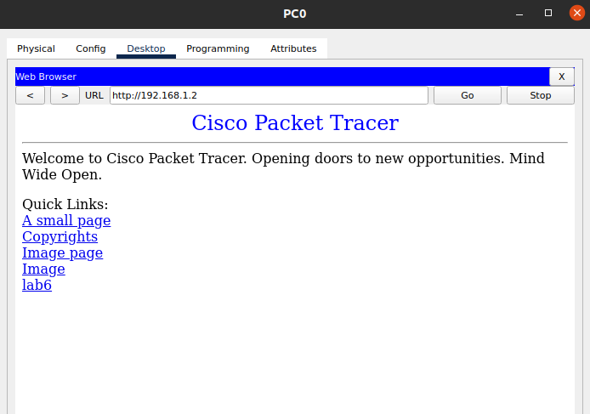

**Result:**

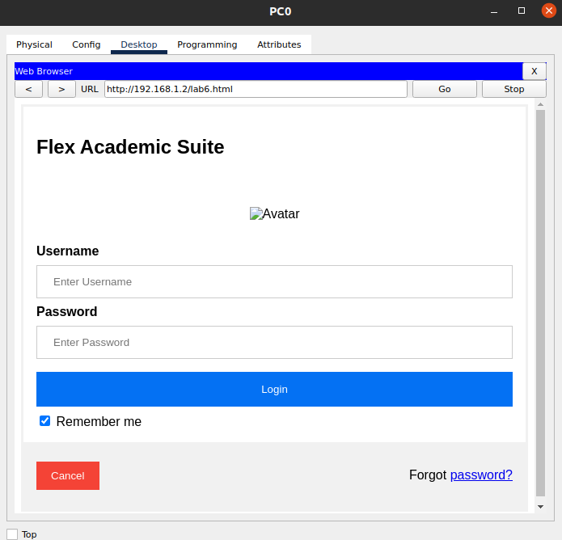

Task #4

Add 3x PCs, 2x switches, 1x router and 4x servers and connect them with cables

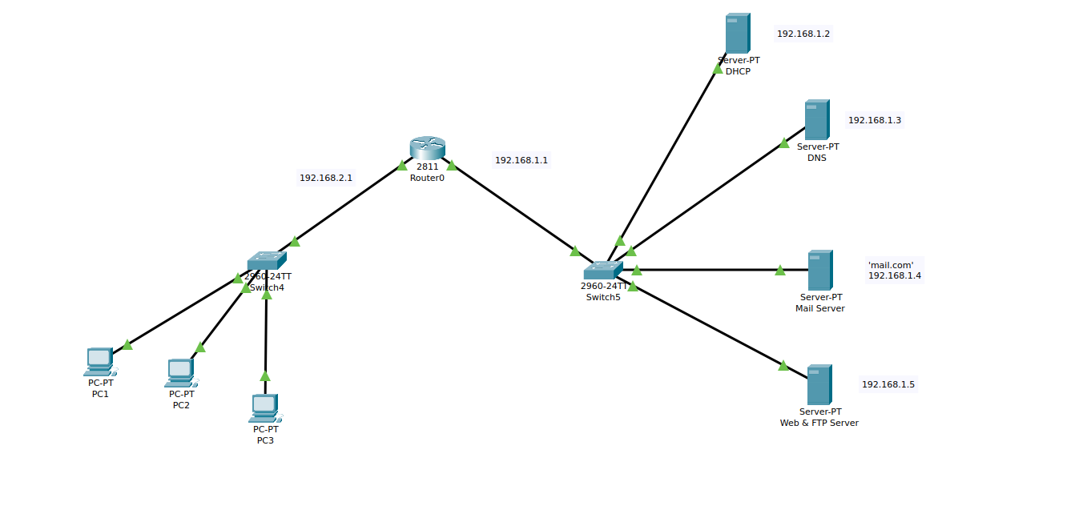

Now we will assign the static IPs to the servers

**DHCP:**

**IP:** 192.168.1.2

**Subnet Mask:** 255.255.255.0

**Default Gateway:** 192.168.1.1

**DNS:** 192.168.1.3

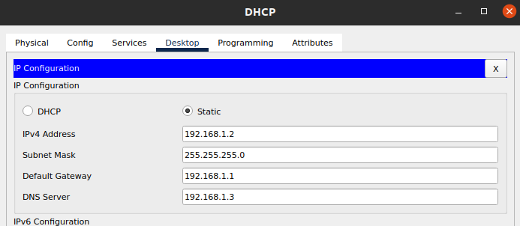

**DNS:**

**IP:** 192.168.1.3

**Subnet Mask:** 255.255.255.0

**Default Gateway:** 192.168.1.1

**DNS:** 192.168.1.3

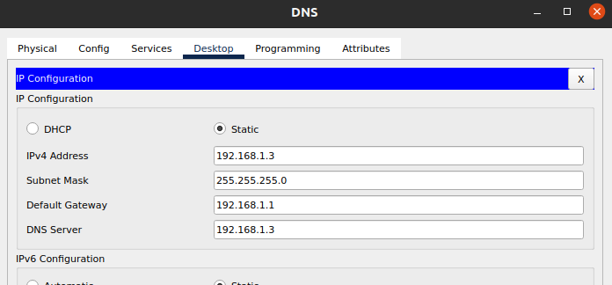

**Mail Server:**

**IP:** 192.168.1.4

**Subnet Mask:** 255.255.255.0

**Default Gateway:** 192.168.1.1

**DNS:** 192.168.1.3

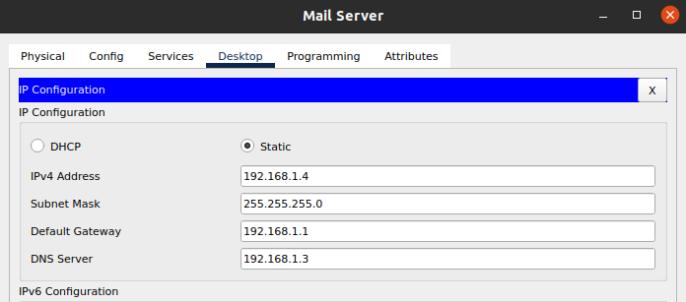

**Web & FTP Server:**

**IP:** 192.168.1.5

**Subnet Mask:** 255.255.255.0

**Default Gateway:** 192.168.1.1

**DNS:** 192.168.1.3

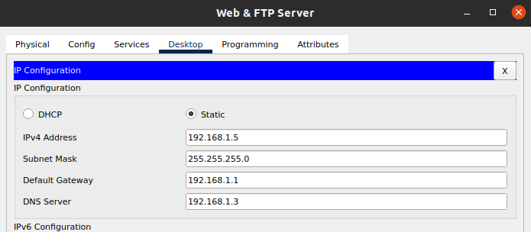

Now we will configure the router.

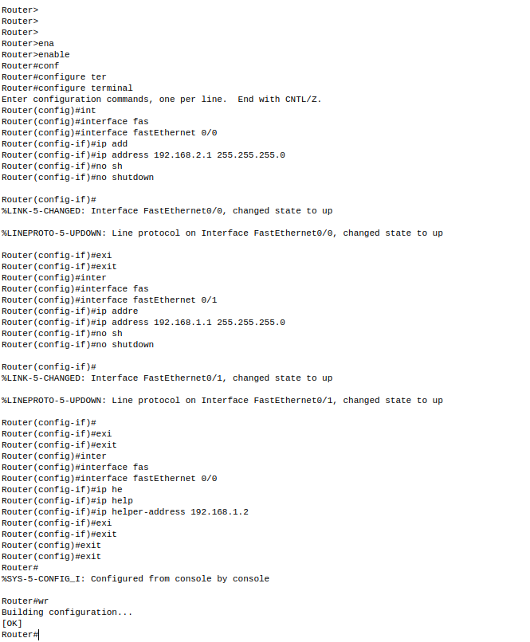

And now just assign the IPs to the PCs using DHCP.

Configuring the severs more.

**DHCP:**

Create a pool for assigning the IPs

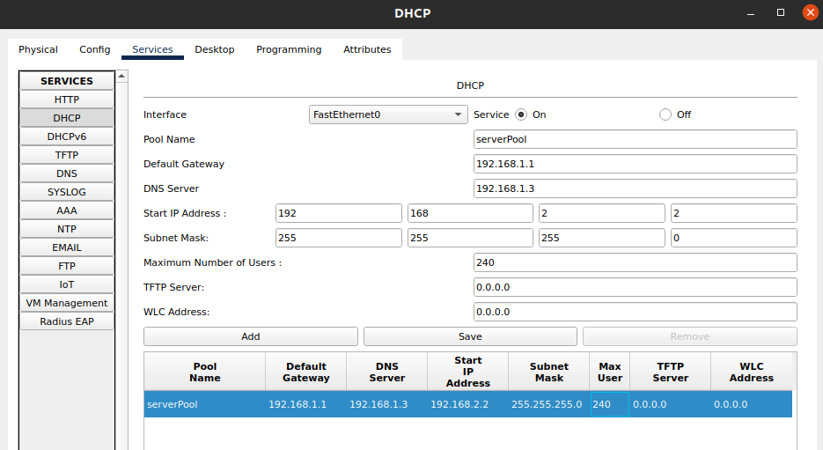

**DNS:**

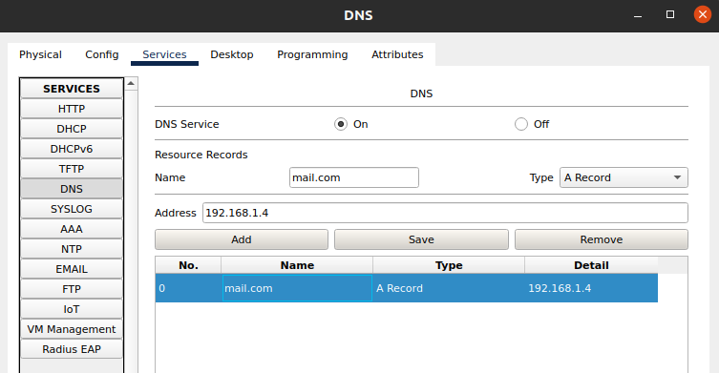

**Mail sever:**

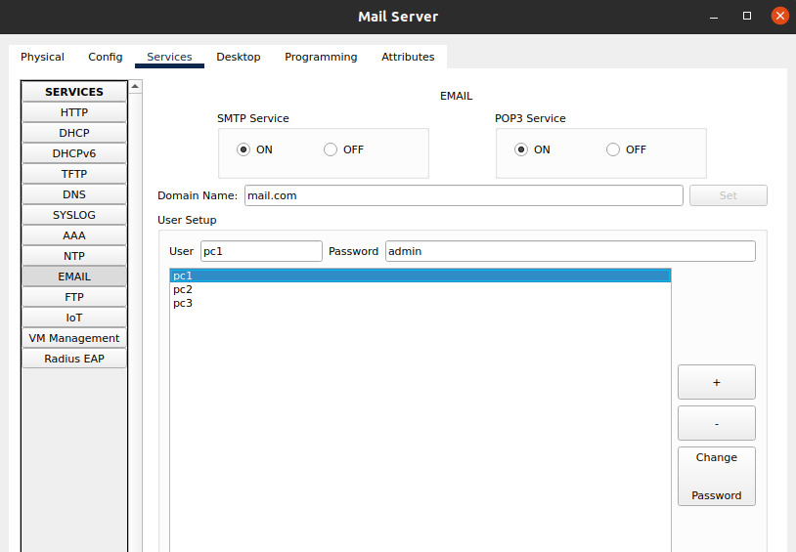

**Web & FTP Server:**

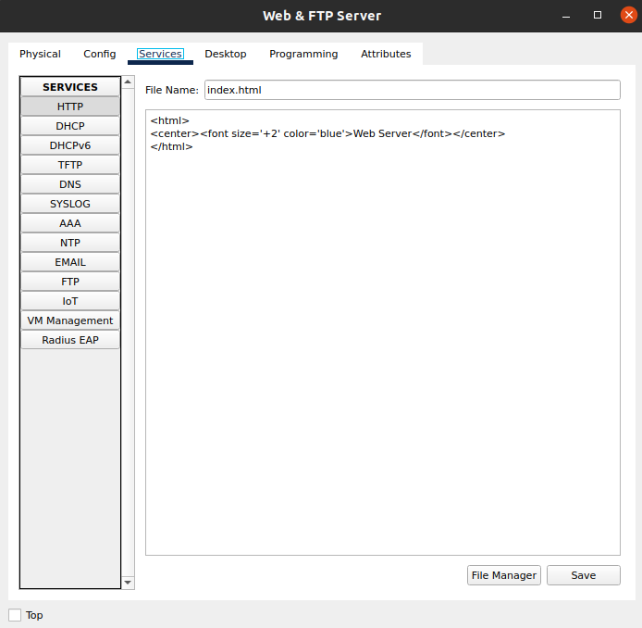

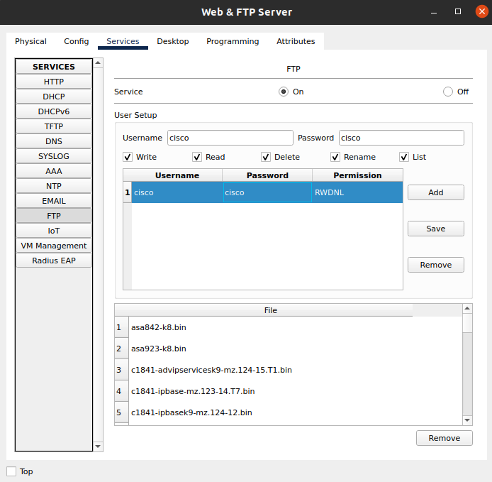

Now we will send an email from pc1 to pc3:

**from pc1:**

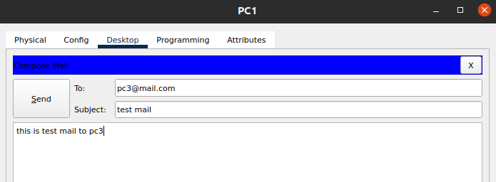

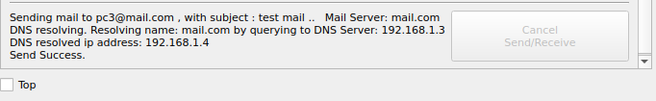

**to pc3:**

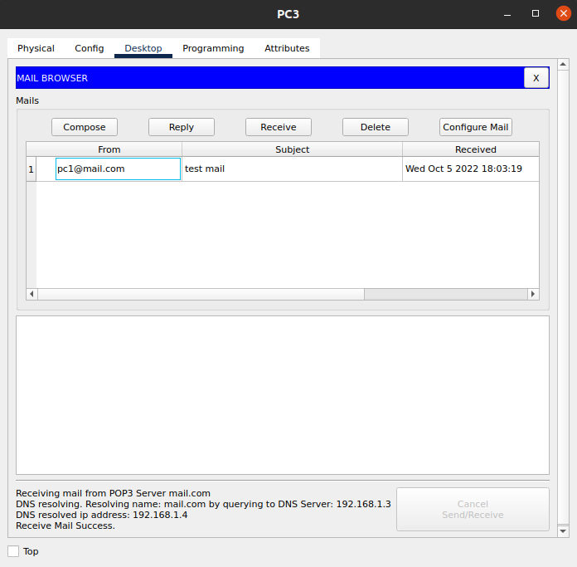

**Sending the file to the sever:**

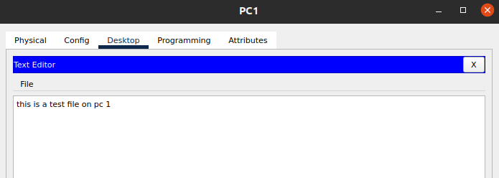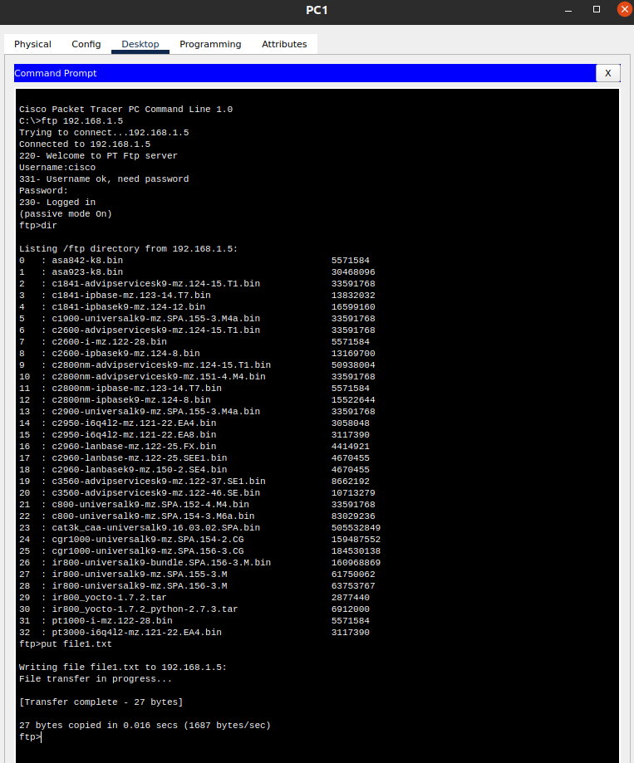

Downloading the file form the sever to the pc2

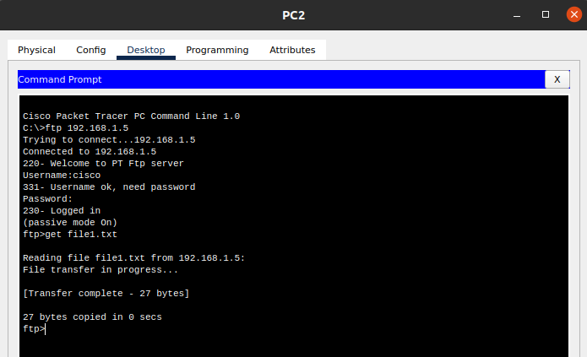

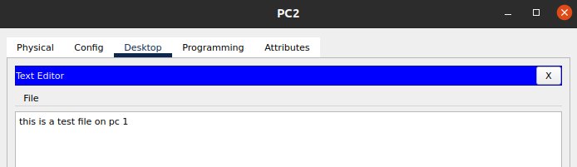

**Accessing the web server from pc 3:**

